**Label Table :** F123_PolyTable_complete.csv 🡪 “my_Poly_data.csv”

|  |  |  |
| --- | --- | --- |
| Poly_number | Number of the polygone | |
| Poly_LabelName | Label name |
| Poly_Longitude | Longitude at the centroid of the polygon |
| Poly_Latitude | Latitude at the centroid of the polygon |
| Poly_Time | Time in datenum at the centroid of the polygon |
| Poly_EsuPingStart | ESU number at the centroid of the polygon |
| Poly_Bottom | Bottom at the centroid of the polygon |
| Poly_depth | Depth of the centroid of the polygon |
| Poly_limit_up | Minimal depth of the polygon contour |
| Poly_limit_down | Maximal depth of the polygon contour |
| Poly_sum_Sa_70 | Arithmetic sum of sA in polygon at 70 kHz |
| Poly_sum_Sa_200 | Arithmetic sum of sA in polygon at 200 kHz |
| Poly_mean_Sv_70 | Arithmetic mean Sv in polygon at 70 kHz |
| Poly_mean_Sv_200 | Arithmetic mean Sv in polygon at 200 kHz |
| Poly_pixel_number | Number of no-null pixels inside polygon |
| FAROFA | Number of the cruise (1, 2 or 3) |
| MPA | Factor: inside or outside MPA : « in » ; « out » ; « off50m » |
| Wind_exposure | Factor : « leeward » ; « windward » |
| distanceToCoast | Distance to the coast in meter |
| distanceToShelfbreak | Distance to the shelfbreak in meter, negative before the shelfbreak (50 m depth), positive after |
| SaFish_70 | Sa Fish of the closest ESU to the centroid of the polygon at 70 kHz |
| SaNoFish_70 | Sa No Fish of the closest ESU to the centroid of the polygon at 70 kHz |
| SaFish_200 | Sa Fish of the closest ESU to the centroid of the polygon at 200 kHz |
| SaNoFish_200 | Sa No Fish of the closest ESU to the centroid of the polygon at 200 kHz |
| Sediment | Sediment type in the closest ESU to the centroid of the polygon |
| Nb_Sediment | Number of sediment types |
| Depth_std | Bottom depth standard deviation |
| Rugosity | Bottom Rugosity over 25m |
| Slope | Bottom Slope over 25m |
| ESU25row | Row number of the closest ESU to the centroid of the polygon in ESU Table |
| Poly_sum_logSa_70 | Log(Poly_sum_Sa_70+1) |
| Poly_sum_logSa_200 | Log(Poly_sum_Sa_200+1) |
| logSaFish_70 | Log(SaFish_70+1) |
| logSaNoFish_70 | Log(SaNoFish_70+1) |
| logSaFish_200 | Log(SaFish_200+1) |
| logSaNoFish_200 | Log(SaNoFish_200+1) |
| SaFish_Other_70 | SaFish_70 - Poly_sum_logSa_70 |
| SaFish_Other_200 | SaFish_200 - Poly_sum_logSa_200 |
| logSaFish_Other_70 | Log(SaFish_Other_70+1) |
| logSaFish_Other_200 | Log(SaFish_Other_200+1) |
| BottomDepthFactor | Factor « eu_upper » ([0-20m]) ; « eu_lower » ([20-40m]; “meso_upper” ([40-60m]);”meso_middle” ([60-80m]); « meso_lower » (>80m) |

1 row 1 polygone

Variable of interest are highlighted in yellow (numerical) and blue (factor)

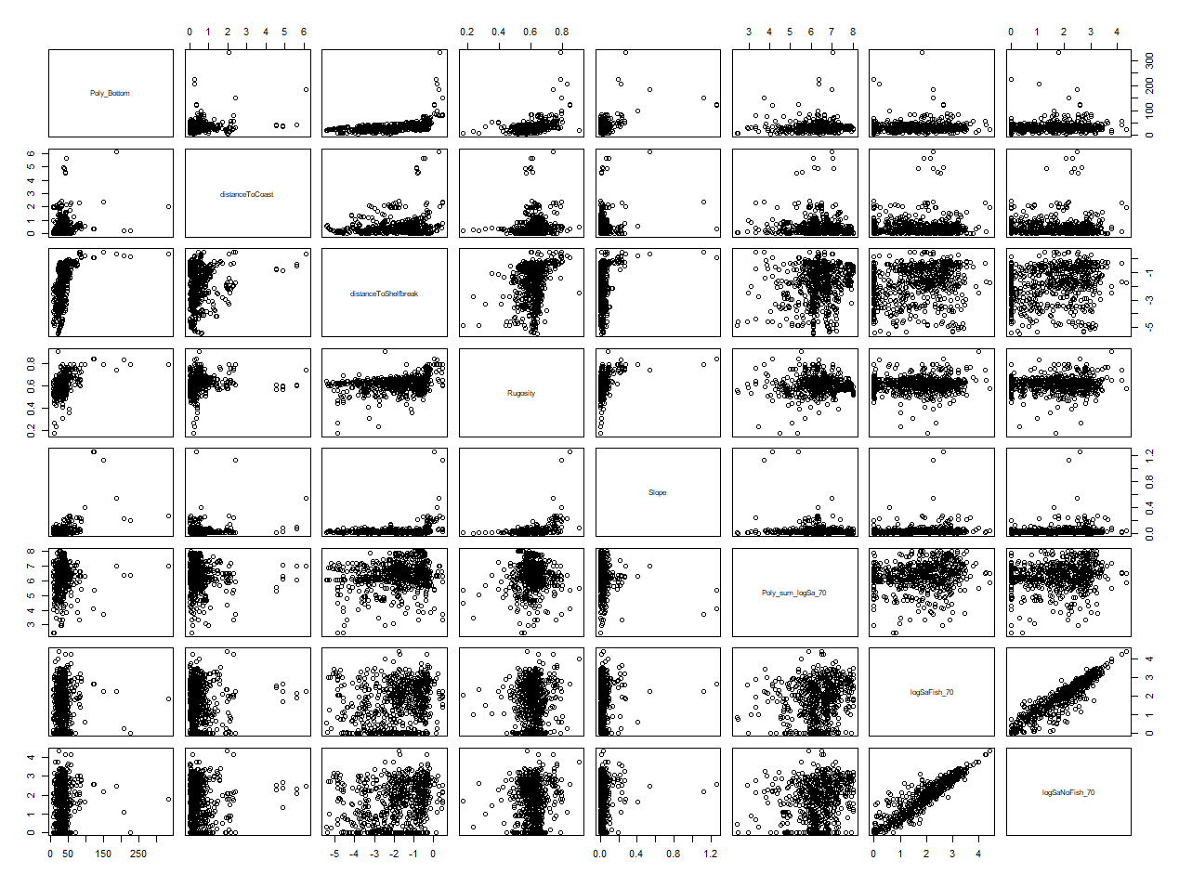

**ESU Table** « F123_Averaged_SaSum_Sed_complete.csv”🡪 “my_ESU_table.csv”

|  |  |
| --- | --- |
| DATE | date |
| interval_vector_char | Character string designs the interval edges in meters , ex.“200-225” |
| interval_edge_diff | Difference with expected right edge and existing data in meter, ex. 225 in “200-225” |
| GPSDistanceMeter | GPS cumulated distance |
| ESU_start | Designe the number of the starting ESU (at 1ping) |
| ESU_end | Designe the number of the ending ESU (at 1ping) |
| nb_pings_by_interval | Number of ping in interval |
| Time_start | Time start |
| Time_end | Time end |
| Lat_start | Latitude start |
| Lat_end | Latitude end |
| Lon_start | Longitude start |
| Lon_end | Longitude end |
| Depth_start | Bottom depth start |
| Depth_end | Bottom depth end |
| Depth_std | Bottom epth standard deviation |
| Rugosity | Bottom Rugosity over 25m |
| Slope | Bottom Slope over 25m |
| Time_mean | Mean Time |
| Lat_mean | Mean Latitude |
| Lon_mean | Mean Longitude |
| Depth_mean | Mean depth |
| SaFish_70 | Mean arithmetic sA fish at 70 kHz |
| SaNoFish_70 | Mean arithmetic sA no fish at 70 kHz |
| SaFish_200 | Mean arithmetic sA fish at 200 kHz |
| SaNoFish_200 | Mean arithmetic sA no fish at 200 kHz |
| FAROFA | Number of the cruise (« 2 », « 2 », « 3 ») |
| Sediment | Sediment type |
| Nb_Sediment | Number of sediment types |
| nbLabel | Number of labels in the ESU |
| MPA | Factor: inside or outside MPA : « in » ; « out » ; « off50m » (port zone) using Lat_mean and Lon_mean |
| Wind_exposure | Factor « leeward » ; « windward » using Lat_mean and Lon_mean |
| distanceToCoast | Distance to the coast in meter using Lat_mean and Lon_mean |
| distanceToShelfbreak | Distance to the shelfbreak in meter, negative before the shelfbreak (50m depth), positive after |
| BottomDepthFactor | Factor « eu_upper » ([0-20m]) ; « eu_lower » ([20-40m]; “meso_upper” ([40-60m]);”meso_middle” ([60-80m]); « meso_lower » (>80m) |

